Messages after filling and submitting the survey form from the “insert_pvq.php” file.

1. When echo("<script>location.href = '../login/login_ok.php';</script>"); is activated (L.314), it goes back to “login_ok.php”



1. When echo("<script>location.href = 'done_exp_test.php';</script>"); it goes to “done_exp_test.php”

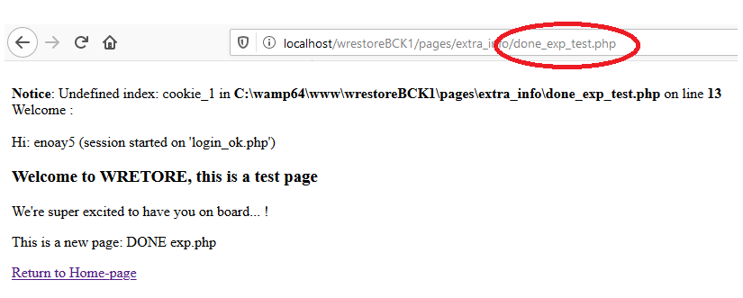

1. When both previous options are as comment, it gives this message

